Thought Seeds

Questions\Discussion for Thought Seed 1:

Thought Seed 1:
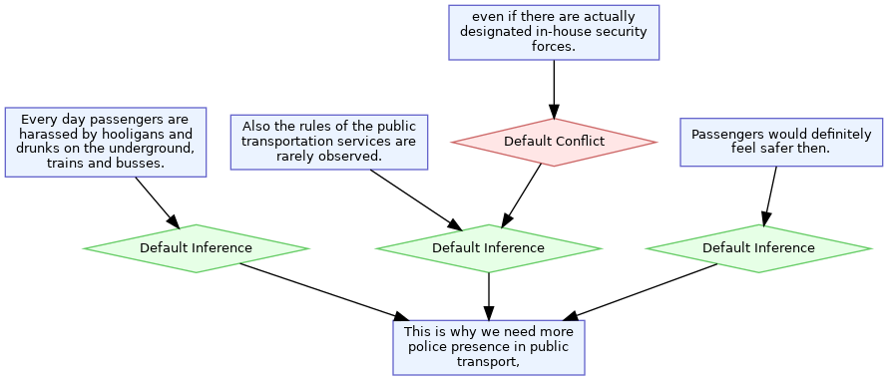
Source of the analysis: Lawrence & Reed, (2014). -AIFdb corpora - http://corpora.aifdb.org/index.php
Have you ever thought why we argue?
Is it a skill natural to humans or have we arrived at its principles eventually to strengthen our arguments?
There are different theories of argumentation and thus different ways of measuring the strength of the arguments. Look at thought seed 1, here an argument is represented using nodes that connect with each other through a support relation or conflict\refute relation.
Does an analysis like this communicate anything to you?
Does it align with your understanding of arguments in any way?
Can such an analysis help us construct better arguments in speech or in writing?
If yes, can you think of aspects from these analyses that are striking to you?
Can analyses like these help you become familiar with new text types?
Or is it too complicated?

Thought Seed 2 a

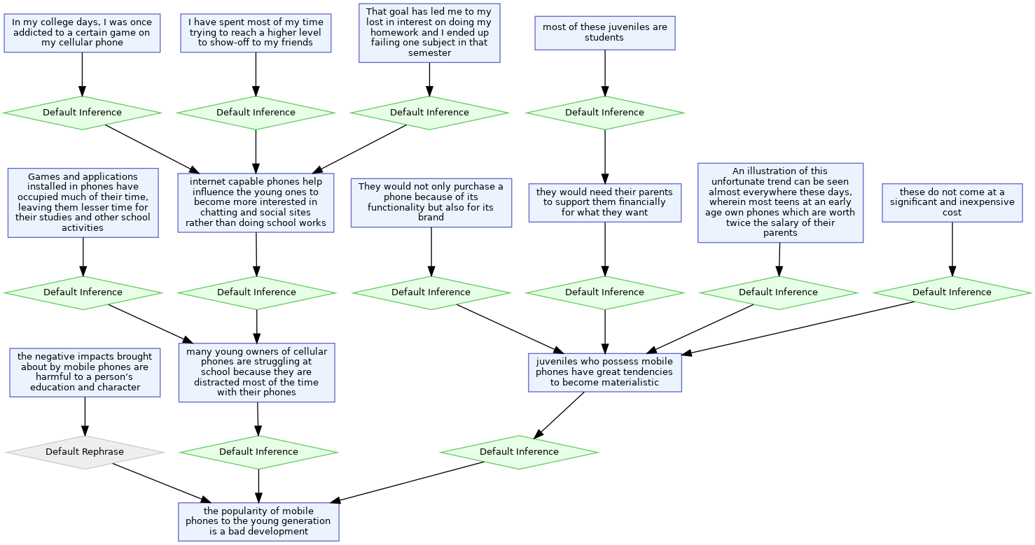
Source of the analysis: Lawrence & Reed, (2014). -AIFdb corpora - http://corpora.aifdb.org/index.php

Thought Seed 2 b
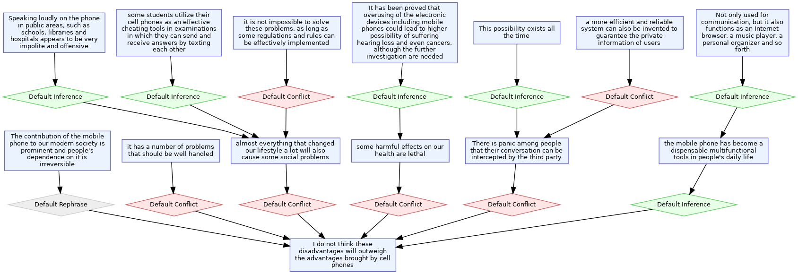
Source of the analysis: Lawrence & Reed, (2014). -AIFdb corpora- http://corpora.aifdb.org/index.php

Questions\Discussion for Thought seed 2:
Look at these analyses of persuasive essays. These are argument diagrams, tree like structures with nodes connected and arranged in levels which show the root node (the major claim) that captures the author’s standpoint on the topic, and arguments in individual body paragraphs that either support or attack the major claim. Each argument in turn has a claim (the central component of each argument) and at least one premise (reasons of the argument), the claims have a stance attribute (for or against) to differentiate between supporting and attacking arguments. Such analyses are used to develop tools using artificial intelligence and computational techniques for domains like education, healthcare, intelligence analysis among many. One such tool is Project Debater (https://research.ibm.com/interactive/project/debater you can look it up if it interests you). They could also be used in the context of argument-based learning. Arguments are not just when we argue per se, they are embedded in our reports, expositions and narratives. It is the logic in the argument that is analyzed here.
Look at thought seed 2 a, b. They are arguments on the same topic but take different routes.
Does this say anything to you?
Do you think that there is only one way of arguing or are multiple responses possible?
Can all responses be right at the same time?
Does it give you an idea about constructing arguments?
Then, what is the key to construct meaningful arguments?
The logic that the statements adhere to?
Does that make our arguments strong and meaningful?
Is organization important? Does logic become clear through organization?
Are these analyses too complicated to follow?
Can any addition to this analysis like the text analyzed given in the right order or an explanation or any other addition you can think of make it more useful?

Notes for Teachers
- Thought seeds are those inputs that expect varied outcomes over longer periods and not immediate or in class applications or results. Thought seeds are often followed by a set of open-ended questions where varied answers are possible or by a set of rhetorical questions. The facilitator could choose to do a whole-class discussion after presenting the thought seed and the questions if the class is interested but should always encourage varied answers and not correct the learners even if the facilitator is convinced otherwise. The essence of a thought seed would be lost if the discussion becomes prescriptive and if it is not an open field for discussing, agreeing and disagreeing freely (Deepa, 2022).

- The facilitator could try to encourage learners to reflect on the key features of arguments using these analyses and engage with them in a whole class discussion or small group discussions if this gains interest. The facilitator could also continue the discussion later if the class is interested with an AI based tool (like Project Debater) by exploring it together (with no real end goal in mind, just to understand how it works).

- After using these thought seeds in the classroom to raise learners’ awareness about arguments and argumentation, could you note down some of the student responses. Please try to capture the trends and patterns in the responses. Under each trend or patterns , provide student responses in quotes where possible and paraphrased otherwise.

- Could you give your feedback by answering the following questions.

- What are your thoughts about such an idea. Do you think it can work in your classroom?
- If yes, Could you explain with reasons.
- If no, Could you explain with reasons?
- If you were to use it in your classroom, how would you improve it? Or what would you do differently?
- If it is not relevant for your classroom, which classroom or group of students do you think it would be better suited for?
- Have you taught the concept of argumentation in your classroom? If yes, could you explain how you have done it and the response from the students.

II. Argument Mapping for Critical Reflection:
Using the argument maps, visualizations, and text analysis in Rowland (n.d.) the concept of argument mapping for the research process is introduced in a session. Some images from the paper are presented below for a glimpse of visualizations.
Students are prepared to make their argument maps for their thesis topics which is the stage 1 assignment for the research course at Master’s level. The assignment not only expects critical reflection on their topic, but also requires clarification of concepts through visualization of their ideas in the form of argument maps. The students have the flexibility to use different tools like Miro, Canva, and manual mapping. They are encouraged to follow the examples in the document discussed in the session and make once such map including the connections between the claims relevant for each section while presenting the overall structure of their research proposal which is their final deliverable for the course.
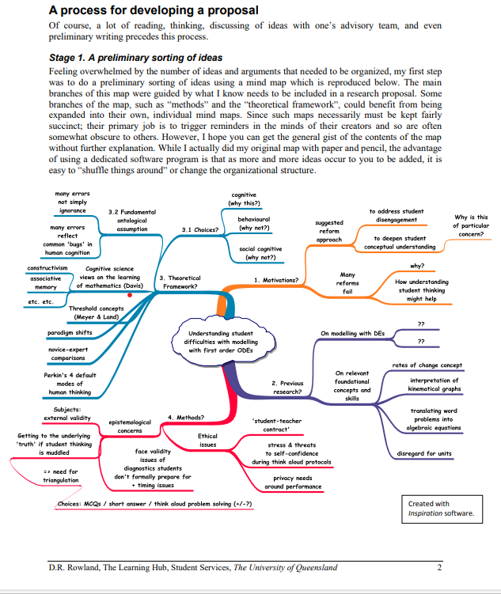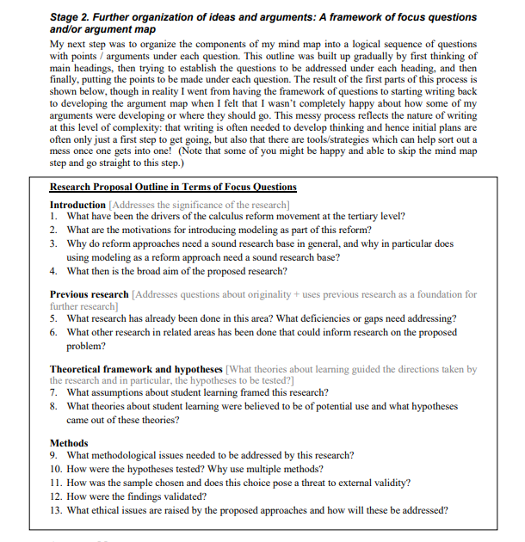

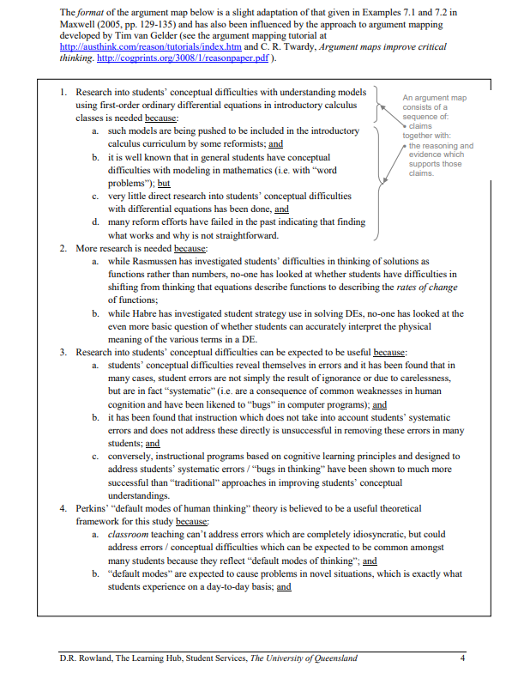

III. Collaborative Argument Mapping:
While a few more applications of this task are being tested, the task example use in Design based education project implementation will be given here.
Step 1: The students produce argument maps detailing one relevant solution for their project challenge initially individually and they get 8 minutes to do that.
Step 2: Once they produce individual argument maps, they exchange their argument maps with the ones next to them taking 8 minutes to edit the map or pose a question. This process is continued till each student goes through all the argument maps in the group twice.
Step 3: The argument maps are discussed in the group to evaluate the ideas to choose a feasible solution aiming at a Minimum Viable Solution.
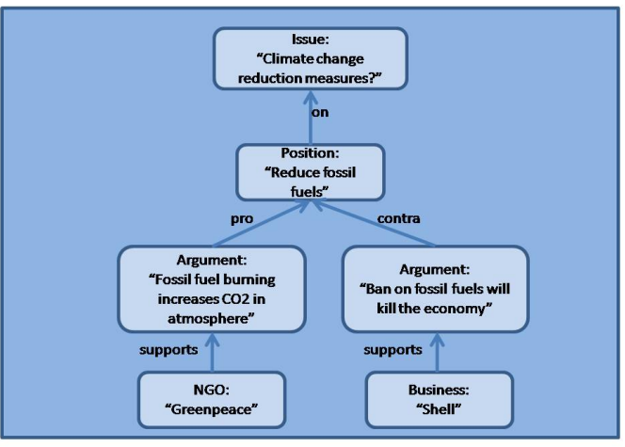
Example argument map (de Moor et al., 2009)
References:
de Moor, A., Park, J., & Croitoru, M. (2009, July). Argumentation map generation with conceptual graphs: The case for ESSENCE. In CS-TIW 2009: Fourth Conceptual Structures Tool Interoperability Workshop @ ICCCS’09 (pp. 58–69). CiteSeerX.
Rowland, D. R. (n.d.). Sample annotated research proposal. The Learning Hub, Student Services, The University of Queensland. https://my.uq.edu.au/files/10720/sample-annotated-research-proposal.pdf
AIFdb Consortium. (2014). AIFdb corpora. Argument Interchange Format Database. http://corpora.aifdb.org/index.php
Lawrence, J., & Reed, C. (2014). AIFdb corpora. Argument Interchange Format Database. http://corpora.aifdb.org/index.php

